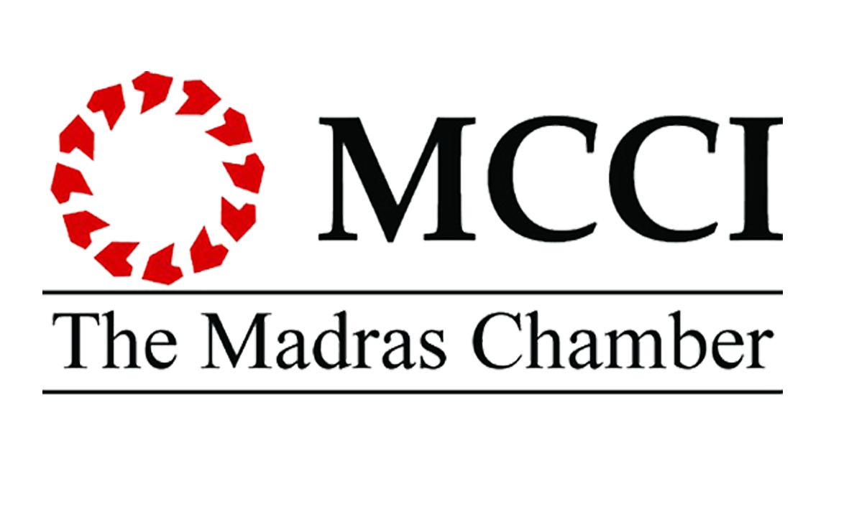

Dear Sir,

An Understanding the Criteria for Performance Excellence
of the IMC Ramkrishna Bajaj National Quality Awards

We are happy to inform you that The Madras Chamber of Commerce & Industry jointly with the Indian Merchants’ Chamber, Mumbai, will organize a program on an Understanding of the Criteria for Performance Excellence of the IMC Ramkrishna Bajaj National Quality Awards process. The program will be held on Wednesday, 15 June 2016, 4:00 pm – 6:00 pm at MCCI Conference Room, Anna Salai, Chennai - 600035.

The IMC Ramkrishna Bajaj National Quality program is seen as a catalyst for nation building. Since the inception of the Awards in 1996, approx. 600 organisations have expressed their intention to apply and 400 of these organisations have gone through the evaluation process. The IMC RBNQA award is given in seven categories: Manufacturing, Service, Small Business, Overseas, Education, Health Care and NGOs.

The IMC Ramkrishna Bajaj National Quality Award Trust is organizing this program as part of the preparation for Indian organizations who wish to enter this contest of world class management in excellence. This is targeted towards CEOs, Function Heads, General Managers and Quality professionals for deeper understanding of the criteria and award process.

The program will be presented by Ms.Maya Desai, Director with the IMC RBNQA Trust and facilitator of the award process.

We hope you will draw benefit from it by participating or also nominating colleagues from your office to participate in the program. Kindly send us the Registration form (enclosed) duly filled at the earliest.

Looking forward to your enthusiastic response.

Yours sincerely,

Arvind Pradhan
Director General

